PART ONE: EXPORTING, EDITING, AND UPLOADING JSON FILES

1. First, check to see if you have access to cPanel by clicking “campus login” and logging in with your UofI credentials: <https://web.illinois.edu:2083/?login_theme=illinois-loginb>
   1. If you cannot log in, contact Jodi and she will get you access.
2. Log in to EPPI-Reviewer:

You can either use the web browser version here: <https://eppi.ioe.ac.uk/eppireviewer-web/home>

Or use Silverlight version here: <http://eppi.ioe.ac.uk/eppireviewer4/eppireviewer4.aspx>

EPPI-Reviewer Silverlight only works with certain browsers. Some information:

“The only requirement is that the computer must be able to run Silverlight 5 and be connected to the internet.  
For optimum performance we would suggest:

Computer: PC or Mac

Silverlight 5+ (latest version preferable)

Supported OS: Windows XP (or newer) or Mac OS 10+

Minimum browser:

On a PC: Internet Explorer 8+, Firefox ESR 3-5

On a Mac: Safari, Firefox ESR 3-5

Chrome will not work as Microsoft Silverlight does not support Google Chrome”

1. Once you’re logged in, open “Retraction Review 2018-07.” Select the data you want to export by using one of the following methods, depending on what version of EPPI-Reviewer you are using.

**In the web browser version:**

Select the “References” tab at the top

Click the small green box that says “Codes” (circled in the screenshot below) on the edge of the right-hand side of the screen

In the menu that pops up, click “Full-text screening” and then “INCLUDE on full study” and then “With this Code” at the top

At the top of the main part of the screen, click “Coding Report”

Check the box that says “Comparison Sets”

Check the box that says “JSON report?” and select the radio button that says “This whole list”

Click “Get Report”

When the report is ready, you may need to hit the save button (underneath the “Get Report” button) to download it to your computer.

You can now move to step 4!

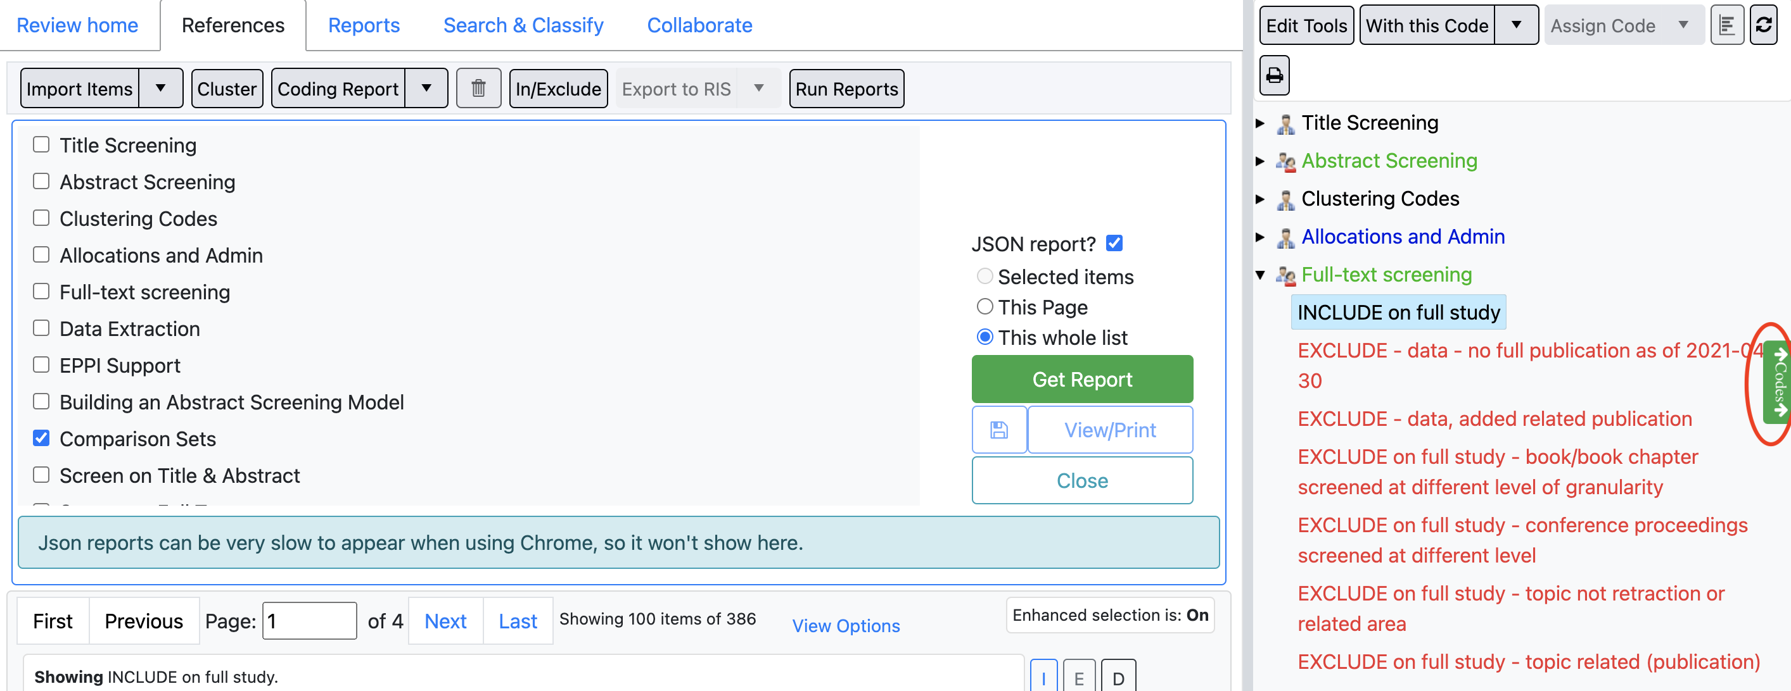

**In the Silverlight version:**

In the box on the right side of the screen, click “Full-text screening”

Right click “INCLUDE on full study” and select “List items with this code”

Select all of the items that appear by checking the box at the top of the list

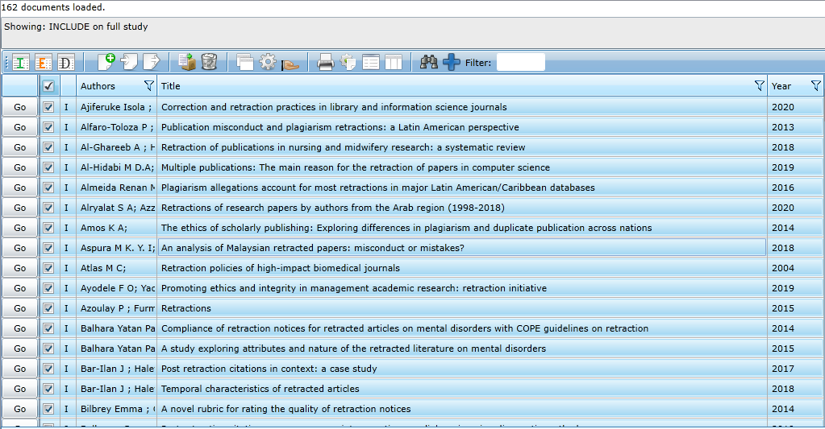

Click on “Get coding report(s) for selected item(s) that have been ‘Completed’

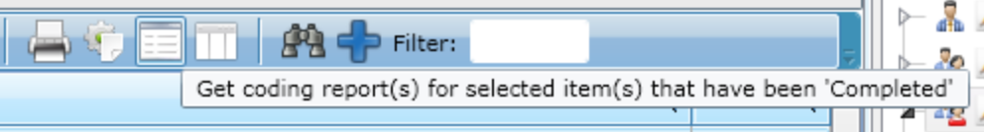

Select “Comparison Sets”

Select “Export Results as JSON text file?”

Click “Get report(s)”

The file may take several minutes to export.

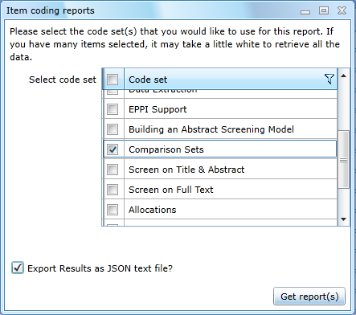

1. Use this Python script to transform export file

<https://github.com/infoqualitylab/EPPI-Reviewer_to_Exhibit_JSON/blob/main/json_pipeline.py>

Before you run it, make sure “infile” in line 4 contains the correct path to the file you exported from EPPI-Reviewer.

If a Unicode error occurs, try using a raw string in line 4 (add an ‘r’ before your file path). For example:

infile = open(r'/Users/randiproescholdt/Documents/Sloan - Python/eppi_export_6.18.2021.json', 'r', encoding = 'utf-8')

1. Upload publications.json using cpanel

Where to upload:

1. Go to <https://web.illinois.edu:2083/?login_theme=illinois-login>
2. Click “Campus login” and enter username and password
3. Click “InfoQualityLab”
4. Under “Commonly Used Features,” click “File Manager”
5. Click “public_html”
6. Double click “**exhibit**” folder (or “**exhibit-test**” folder if you are doing a test run)
7. Double click “metadata” folder
8. At the top of the screen, select “Upload”
9. Upload the file—make sure file name is publications.json—and select “yes” in the dialog box to overwrite the file

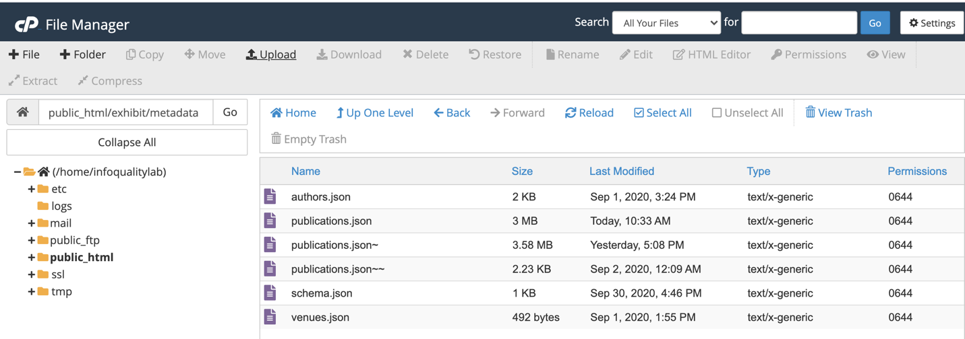

*FYI: The Exhibit JSON file formats (authors.json, publications.json, schema.json, venues.json) are based on the Exhibit publications site of David Huynh (less his CSS):*

[*http://davidhuynh.net/publications*](http://davidhuynh.net/publications)

This will show up at

<http://infoqualitylab.web.illinois.edu/exhibit/> (public facing version) or <http://infoqualitylab.web.illinois.edu/exhibit-test/> (test site)

Make sure the content you uploaded is appearing and the correct number of items are in the bibliography. Sometimes you may need to refresh the page, clear cookies, or view it in a different browser.

This is pulled into the RISRS2020 in an iFrame <https://infoqualitylab.org/projects/risrs2020/bibliography/>

PART TWO: EDITING INDEX.HTML

1. Log into cpanel and download the index.html file if you don’t already have it.

1. Go to <https://web.illinois.edu:2083/?login_theme=illinois-login>
2. Click “Campus login” and enter username and password
3. Click “InfoQualityLab”
4. Under “Commonly Used Features,” click “File Manager”
5. Click “public_html”
6. Double click “**exhibit**” or “**exhibit-test**” folder
7. Double click on the icon to the left of the word “index.html”--this should download the file.
8. Open the file on your computer with a text editor such as Notepad++ or any other app that works to edit html files.

2. If you want to “comment out” anything in the file (i.e., to prevent it from affecting the website, but leave it there for future reference):

a. Add <!-- at the beginning, and --> at the end of the portion you want to comment out

b. The enclosed portion should change color

c. For example, see the green portion in the screenshot below, where the Location filter has been removed for now.

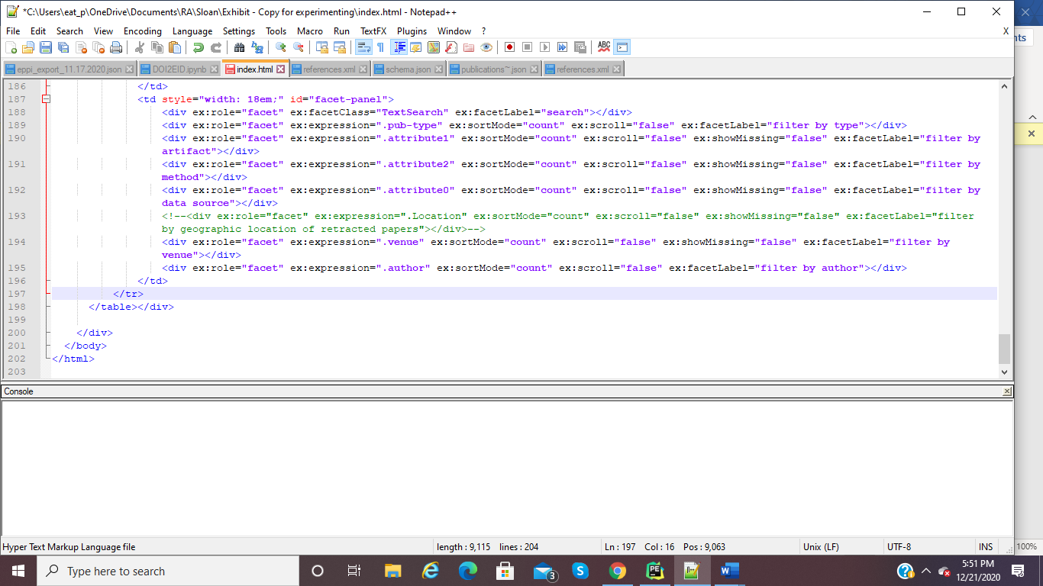

3. If you want to add a new filter, you will need to edit the portion depicted in the previous screenshot. You can find it in the bottom of the html file.

c. Edit the information in ex:expression= to specify which field you are pulling from. This needs to read exactly as it does in the JSON file. It may be helpful to copy and paste from the “Available Filters” list printed out at the bottom of the Python console after you run the .py file.

d. Edit the information in ex:facetLabel= to specify what you want the publicly visible name for the filter to be. This is more flexible and can be anything you want.

e. Here is an example where I created a new field for “Findings Relate To”, or attribute5.

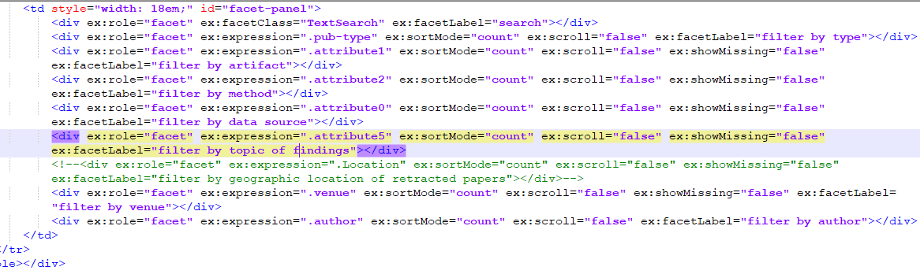

Here’s how the filter appears in the website:

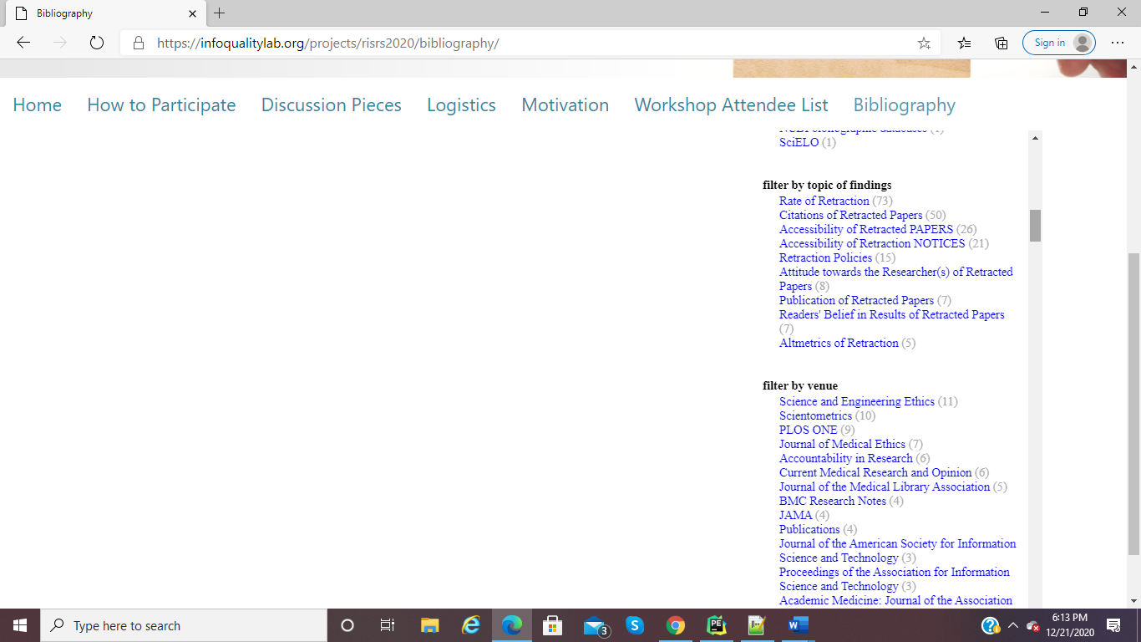

f. Note that you can create filters for any of the fields in the JSON file—both the Comparison Set codes and any other citation information that is listed. The filters appear in the order they are listed in the html file.